MACM 316 – Computing Assignment 8 Report

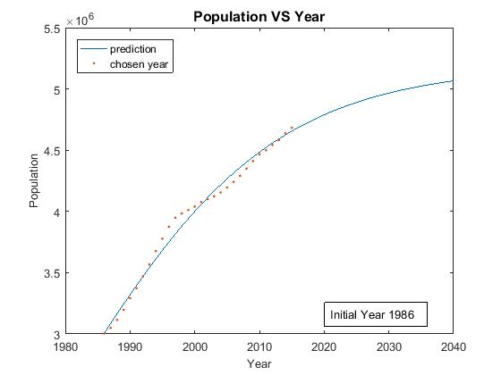

As shown from the top figure on the left, the overall population prediction turns out to be a log scale figure when we take the initial year 1986 into account. This implies that the growth of population of British Columbia will gradually slow down when it approaches year 2040. However, referring to the logistic equation that is based on limited resources approximation, this slowing down phenomenon is not a desirable outcome for the upcoming 25 years, because British Columbia sure has not yet reached its carrying capacity. Hence, it should not have a leveling off effect when approaching 2040 regarding resource-wise aspects. In another words, British Columbia has enough resources to grow its population so the population should not level off when it reaches year 2040.

Looking at the last figure on the left, the overall population prediction grows exponentially when we take initial year 2010 into account. This outcome is clearly not possible because British Columbia only has limited amount of resources for its population to grow. On the other hand, the chosen years’ data points clearly were not sufficient enough to make a good prediction. Therefore, the prediction is off.

Now looking at the middle figure on the left, the overall population prediction grows linearly when we take initial year 1995 into account. This implies that the population keeps growing when it approaches year 2040 without slowing down. This is a fairly reasonable population prediction because British Columbia does have enough resources for its population to grow linearly. Therefore, based on the logistic equation, I believe that the population prediction of British Columbia with initial year of 1995 is the best among all strictly because it

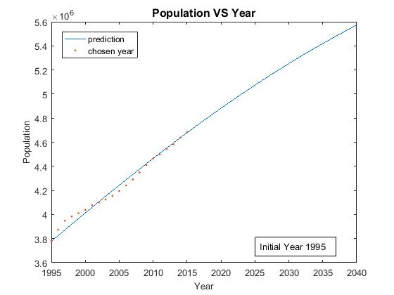

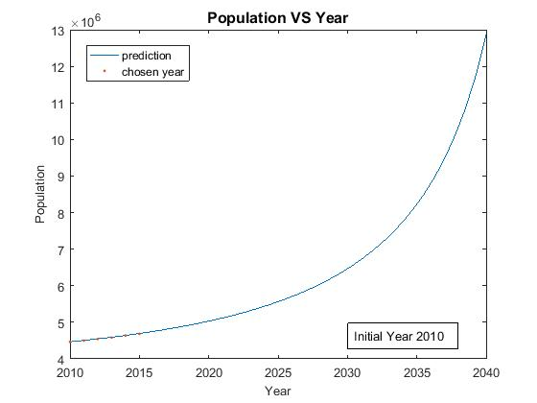

has sufficiently enough data points to have a fairly good prediction and it is also reasonable for the population to grow linearly for the upcoming 25 years referring to the logistic equation with resource-wise aspects. The population prediction of year 2040 with initial year 1995 is 56000000.